=====12/11/2022=====

Group ID: 07

Project name: Cadger

Prepared by: **Nguyễn Khải Phú**

Team members:

20127124 - **Đặng Bảo Châu** *Project manager*

20127062 - **Nguyễn Khải Phú** *Process engineer*

20127068 - **Hồ Minh Thanh Tài** *Business Analyst*

20127045 - **Võ Đình Khôi** *Test Manager*

20127406 - **Thái Cẩm Phong** *Software Engineer*

# **Summarize**

Everyone worked well and met their deadlines. Phong and Chau have almost completed implementing the UI part

1. **Screenshots of all tasks**

* Bảo Châu

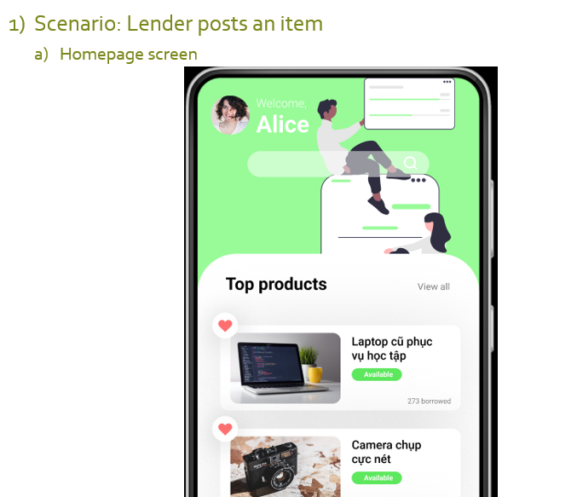

* Khải Phú

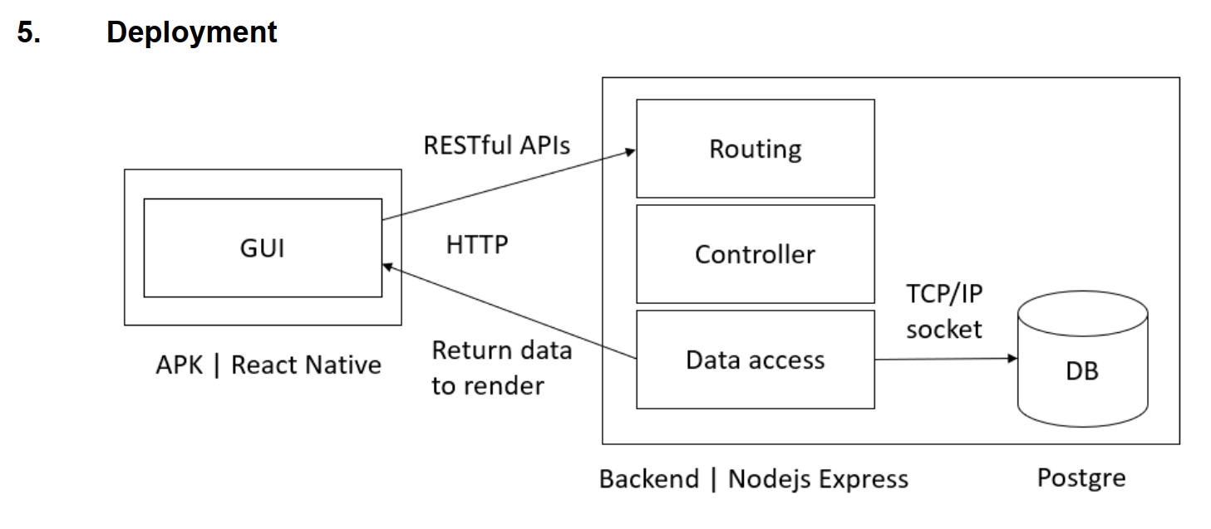

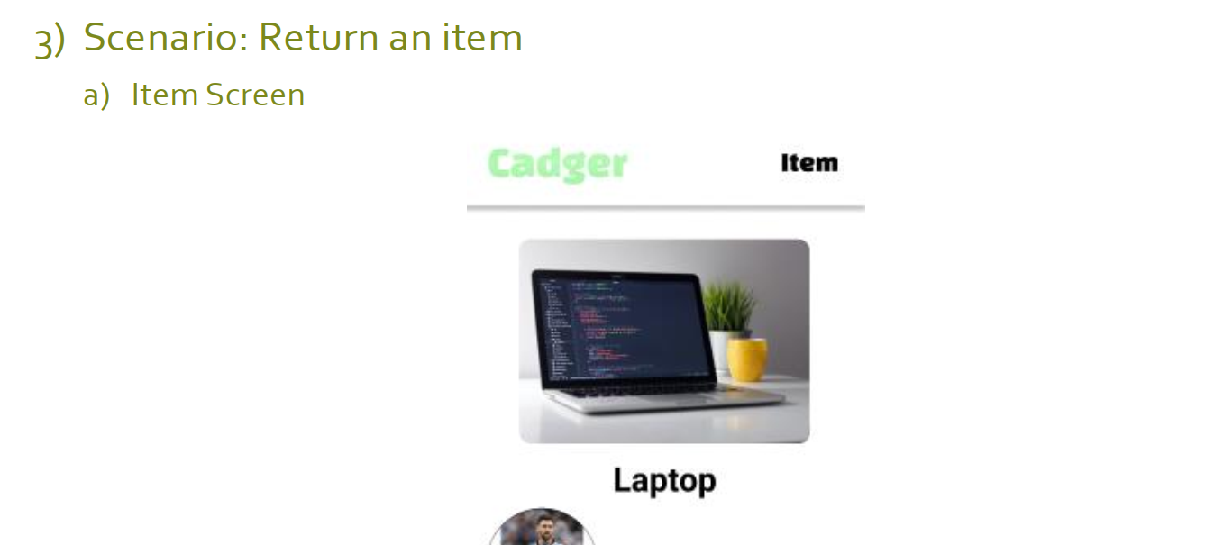

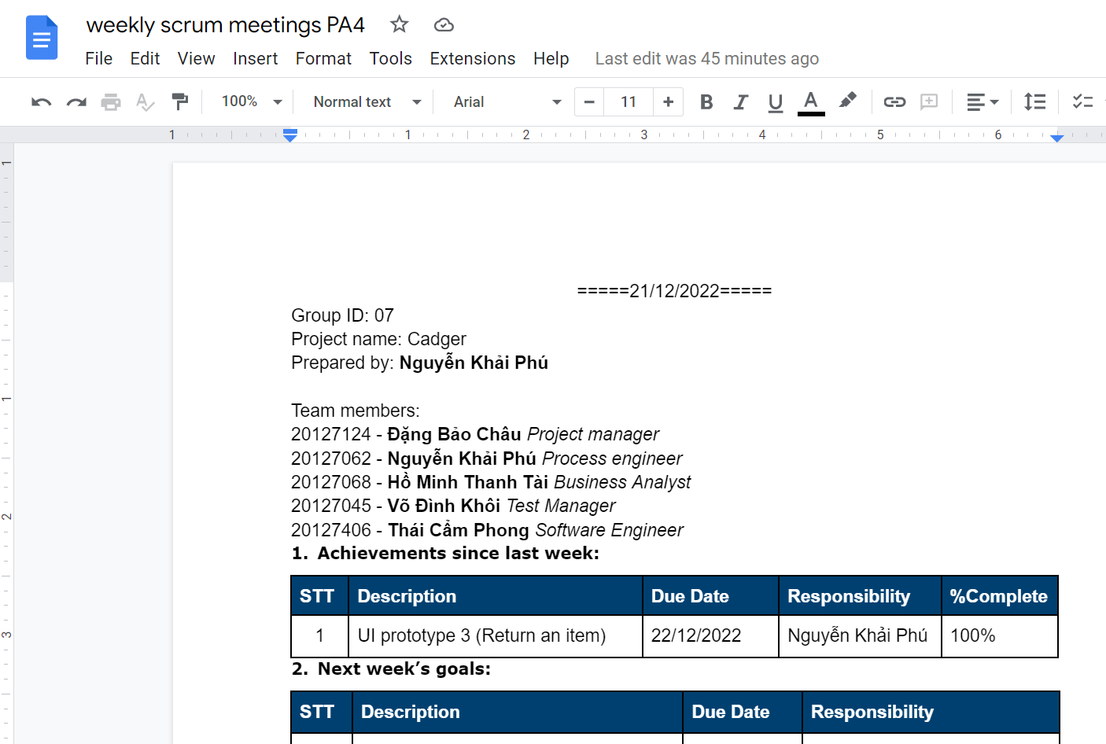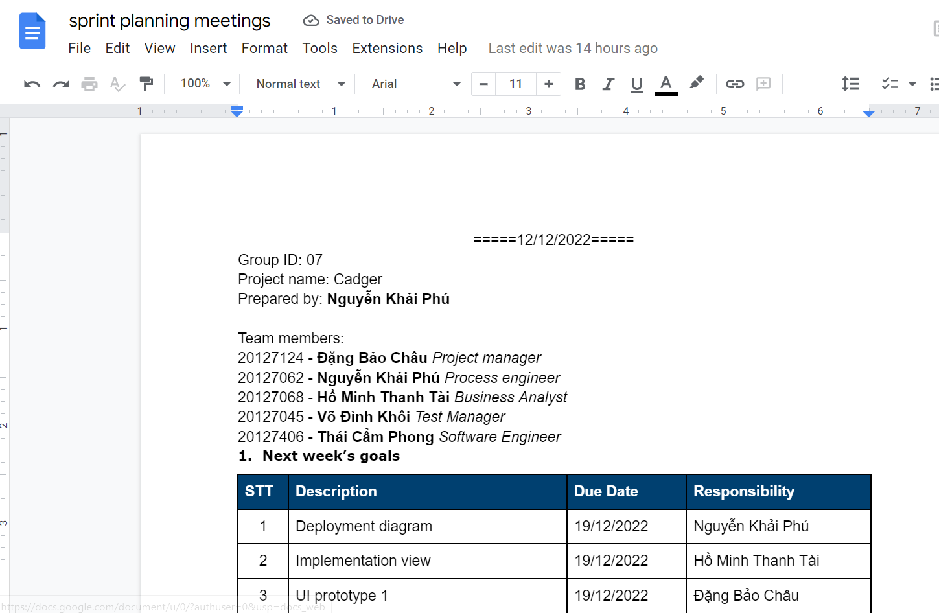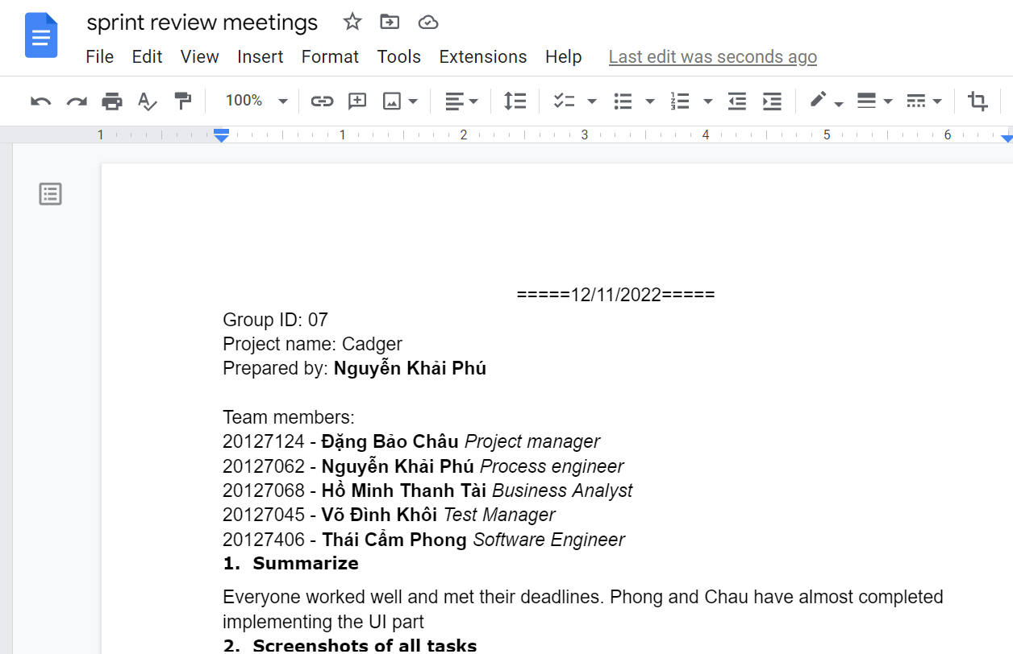

* Cẩm Phong

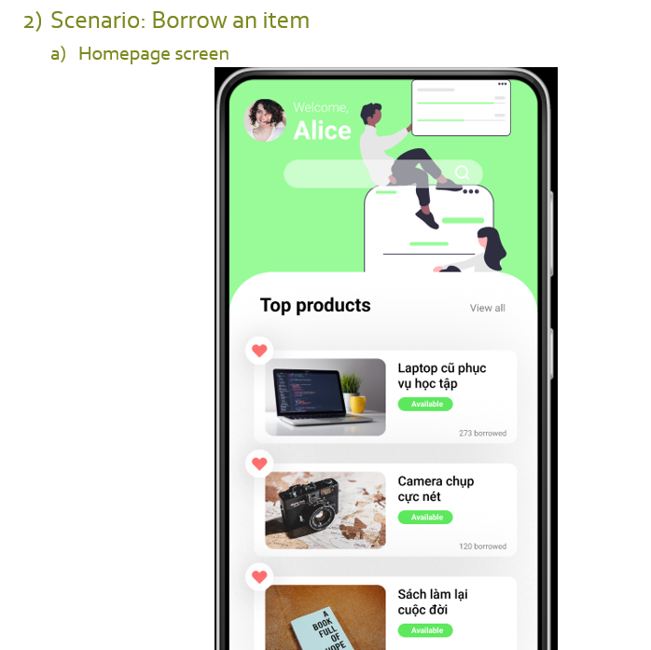

* Đình Khôi

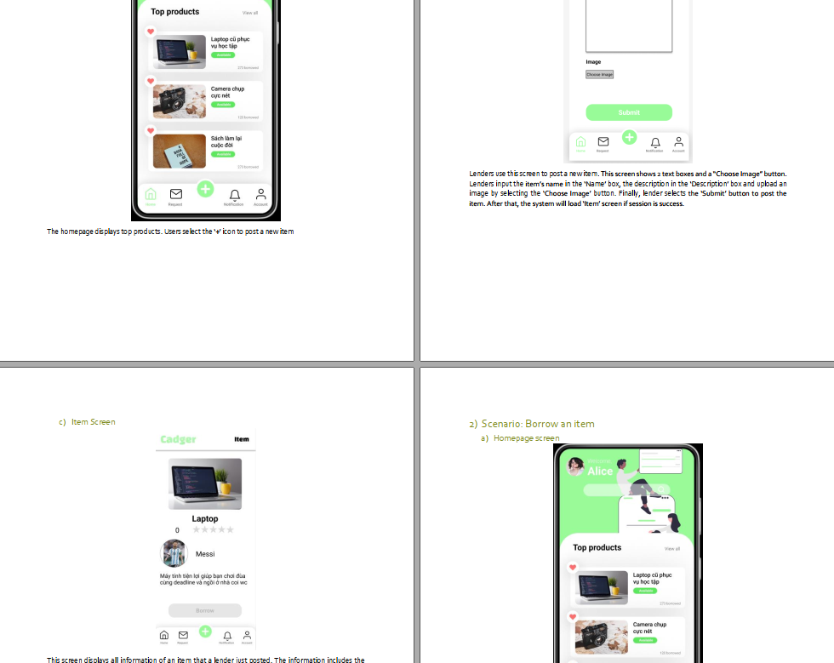

* Thanh Tài

